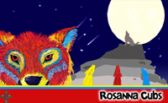

Rosanna Cubs
THIRD Pack Holiday
Gilwell Park, Gembrook

Fri 12th -Sun 14th Nov, 2010
Cowboys & Indians! Final Details


Hi. After the fantastic fun we had last year, it’s time for Rosanna Cub Scouts THIRD Pack Holiday. With a theme of Cowboys and Indians, we’re travelling to Gilwell Park Scout Camp, near Gembrook. We need some Cowboys and Indians to go back to the Wild West – and you’re invited! Come along as we go to the hills around Gembrook – to have the best fun ever!

Location: Gilwell Park Scout Camp, Launching Place – Gembrook Rd, Gembrook
About it: We will be staying in the E.M. Derrick Pack Holiday Centre, comprising Bunk rooms, which will easily accommodate our Cubs in boys only/girls only rooms, plus separate male and female accommodation for Leaders and helpers. Also, Kitchen, dining room, toilet and shower facilities. The Scout Camp is in a bush setting with plenty of onsite activities for our Cowboys and Indians.

Transport: We will travelling by bus, and 1-2 cars will also be going.
Cost: $80 – includes transport, accommodation, food and activity equipment
Leaders: Our Leaders will be attending, plus volunteer parents for Cooking.
Depart: Meet at the Scout Hall at 6pm, Fri 12th Nov. - Ready for a 6:30pm departure.
Return: 1:45 pm Sunday, 14th Nov – depart from Gilwell
3:15-3:30 pm arrive back at Scout Hall.
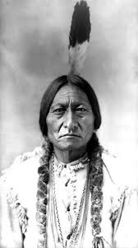
Take: Dormitory Kit list is available on the paperwork/downloads page
of our website ( http://www.rosannacubs.org/paper.htm ). Dilly bags, plates & cutlery not needed. If buying anything from Rays, say that you’re a member of Rosanna Scout Group and ask for our members discount
NOTE: All our Cowboys and Indians can bring along an appropriate costume if they like.
ALSO, very old clothes for the Battle of the Little Big Horn (flour fight) and, depending on weather, we will do the Gauntlet – clothes will get lovely and dirty and very wet
AND large plastic bags for safe return of the clothes home!
FINALLY, the forecast for the weekend is for rain both days – please pay particular care to the need for waterproof rain gear.
Health Form: ALL ATTENDING MUST BRING A FILLED OUT HEALTH FORM ON FRIDAY – Including ADULTS!!!
– see our paperwork/downloads page http://www.rosannacubs.org/paper.htm
NO: Phones, MP3 players, electronic games, radios or similar may not be taken.

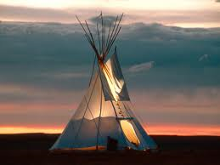
Regards

The Leaders
Rosanna Cub Scouts See us at http://www.rosannacubs.org

Please note: Our original permission slip asked for details on any special dietary requirements. If you have not yet informed us of these, please call Akela on 0411 121 495 and advise Immediately!

